Assignment 1: Data preprocessing

Name: Radha R. Gulhane

GR No. : 1710387

Roll No. :54

1.Importing dataset

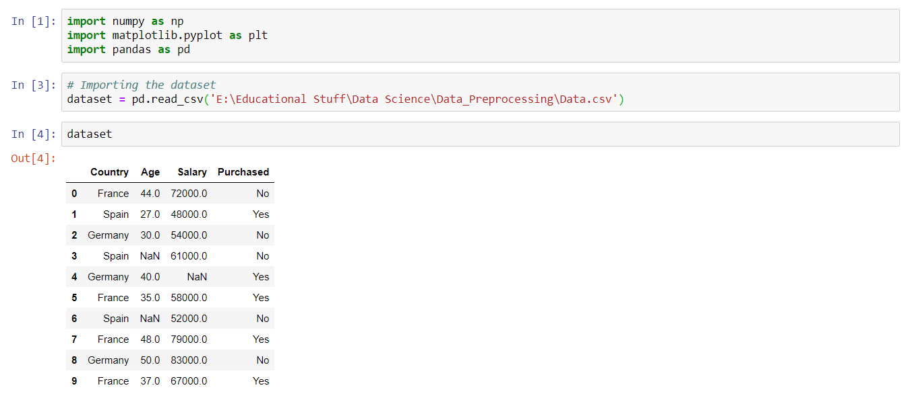

2.Selecting dependent and independent variables

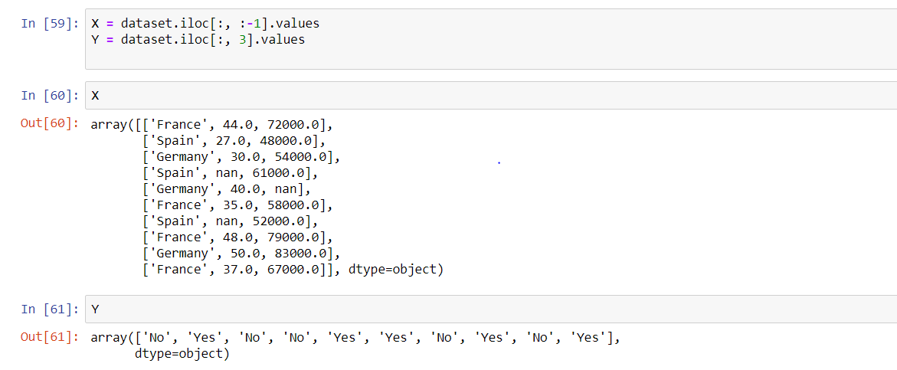

3. Handling missing values

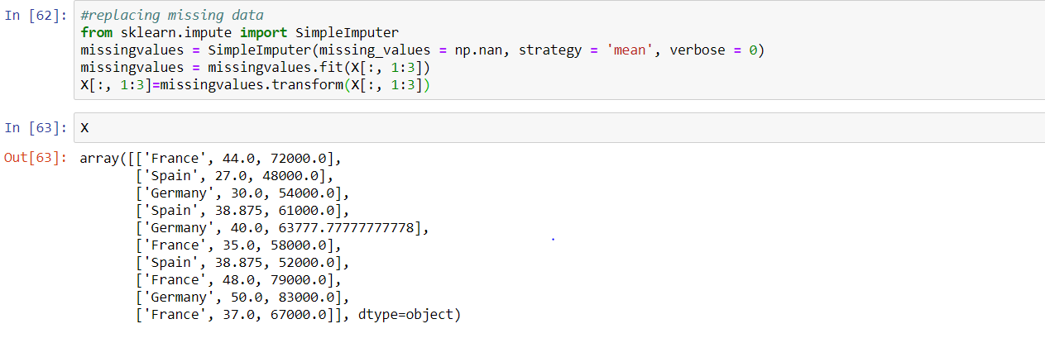

4.Encoding categorical data

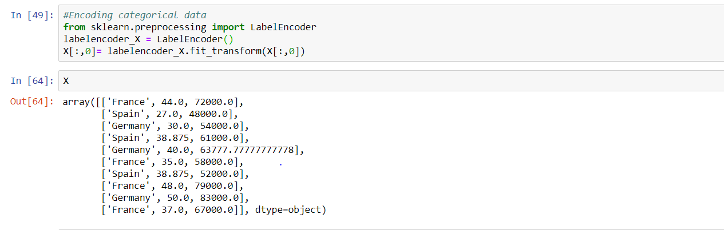

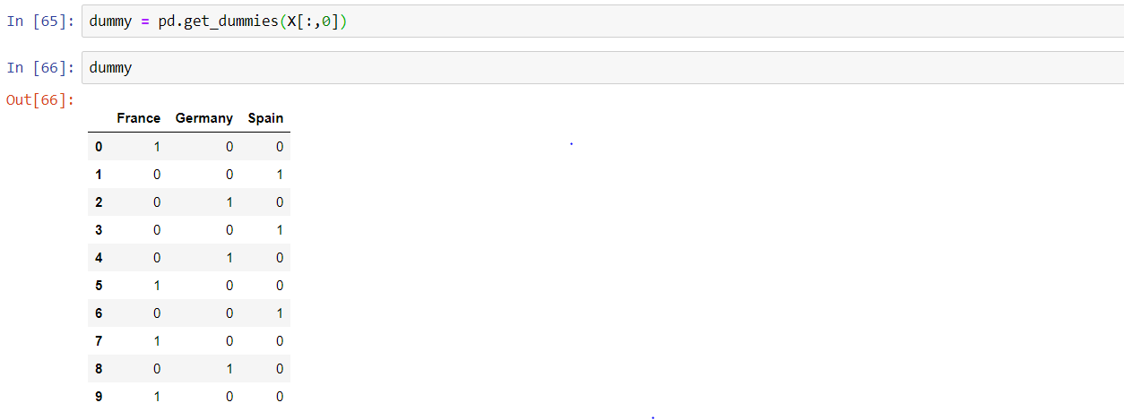

5.Splitting dataset into training and test set

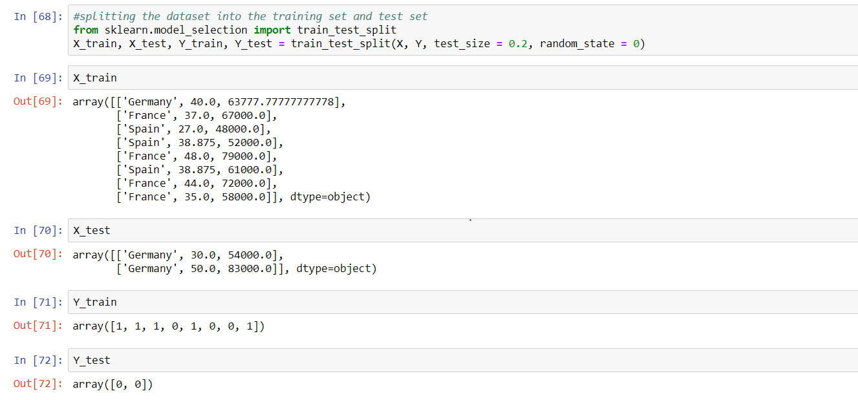

6.Feature Scaling

